Year III: Developing OCTOPAS –
A Novel Method for Oil Spill Cleanup Through an Optimized Pragmatic Automated System
Monish Saravana Kumar Divya Sundari
Florida

Preliminary Matters

Abstract
Oil spills are an urgent global problem that has been worsening over the last 4 years (ITOPF., 2023b). Devastating nearby ecosystems and disrupting economies, they can contaminate water and cause long-lasting damage. For example, the multibillion-dollar fishing industry is affected severely by oil spills. Despite the development of efficient sorbents, the method of sorbent deployment ultimately decides the effectiveness of cleanup efforts. OCTOPAS (Oil Spill Cleanup through an Optimized Pragmatic Automated System), is a novel sorbent deployment method which cleans up oil spills much more efficiently than conventional methods. OCTOPAS has 2 main components, a digital app and a physical boat. Using a novel algorithm, OCTOPAS App generates the optimal path to deploy the sorbents. OCTOPAS Boat gets this instruction and deploys sorbents pragmatically. Using OCTOPAS to deploy sorbents is on average 217.9% more efficient than the conventional method. In the real world, OCTOPAS can be stowed on oil tankers, ready to be used immediately. This immediate deployment can limit the spread and improve the efficiency of oil spill cleanups by a significant margin.

Table of Contents
Preliminary Matters 1
Abstract 1
Table of Contents 2
Key Words 3
Abbreviations and Acronyms 3
Biography 3
Introduction 3
Materials and Methods 6
Results 9
Discussion 12
Conclusions 13
References 15
Bibliography 16

Key Words
Oil Spill –A release of oil (usually crude oil or petroleum) into the environment, typically into bodies of waters such as oceans or lakes. This may happen due to accidents during transporation, drilling of oil, natural disasters, etc. (National Oceanic and Atmospheric Administration, 2020)
Aerogel – A synthetic sorbent, that is 99% air. It is a highly efficient sorbent for oil spill cleanups, as discovered through my past research. The aerogel used in this experiment was silica aerogel, which is one of the many types of aerogels (Aerogel.org., n.d.)
Peat Moss –A natural, environmentally friendly, biodegradable sorbent that is used for oil spill cleanups. Peat Moss comes from bogs, and the type of peat moss used in this experiment was canadian sphagnum peat moss. (PeatSorb Safety Data Sheet, 2018)
Conventional Method – The typical method of oil spill cleanup used in the real world. The average amount of oil recovered using these methods is less than 30%

Abbreviations and Acronyms
OCTOPAS - Oil spill Cleanup Through an Optimized Pragmatic Automated System
OCTOPAS is a novel sorbent dispersion method, built by the researcher.

Biography
My name is Monish Saravana Kumar Divya Sundari. I’m a freshman at Orlando Science Schools. In my free time I like to code, listen to music, and play video games. One of the major fields I want to explore is AI, more specifically natural language processing. I’m eager to use my skills to make a lasting impact on the world.

Introduction
An alarming revelation was made in the latest study by ITOPF (ITOPF., 2023b) International Tanker Owners Pollution Federation) in 2023 - Oil spills have relentlessly increased worldwide. Surprisingly, over 15,000 tonnes of oil were spilled into the ocean just last year, with a meager 30% recovery rate . The magnitude of the catastrophic effects caused by these spills make it a critical, global issue that demands immediate attention.
Oil spills are a grave danger to marine life, with devastating effects on individual animal’s health and the ecosystem as a whole (NOAA, 2021), (Edmond, C. 2021). The toxic fumes emitted by spilled oil can poison animal’s lungs and immune systems, while physical exposure can cause suffocation and hinder reproduction. The negative effects on the region's flora and fauna can be catastrophic, as the ecosystem does not have enough time to adapt to the sudden change. The consequences can be long-lasting, leading to the potential collapse of entire ecosystems. The contamination of water affects both marine animals and humans, posing a serious threat to health. The economic damage caused by oil spills is also significant, disrupting the fishing and tourism industries, which generate billions of dollars in revenue.
In the fight against oil spills, current research has primarily focused on developing highly effective sorbents. However, even the best sorbents can only do so much. The key to a successful oil spill cleanup lies in the deployment method of the sorbent. Despite the best efforts of conventional methods, a mere 30% of spilled oil is recovered, using the most efficient sorbents. This leaves much room for sorbent deployment methods in oil spill cleanups. OCTOPAS is a sorbent deployment system that is optimized, pragmatic, and automated. The goal of this project was to create a method that would drastically improve the efficiency of oil spill cleanups, and OCTOPAS has exceeded the engineering goals set. With its implementation, oil spills cleanup efficiency can be significantly improved, and meaningful impact on this global crisis.
OCTOPAS is a novel automated system that will be able to clean up each oil spill pragmatically, based on the situation. How exactly does OCTOPAS work (figure 1)? Firstly, if an oil spill occurs, pictures of the oil spill will be taken using a drone. Next, these images would get processed by an image processing algorithm (OCTOPAS App) in the OCTOPAS App. This image processing algorithm distinguishes the oil from the water, and analyzes the image, for the area of the spill and to calculate the optimal path for the OCTOPAS Boat. Once this algorithm has processed the image, a wireless Bluetooth message will be sent to the OCTOPAS Boat, which is loaded with sorbents. Based on these images, the boat will move through the oil spill, dispensing sorbents, which cleans it up. The analytics of OCTOPAS, will be transmitted to the OCTOPAS app in real time.
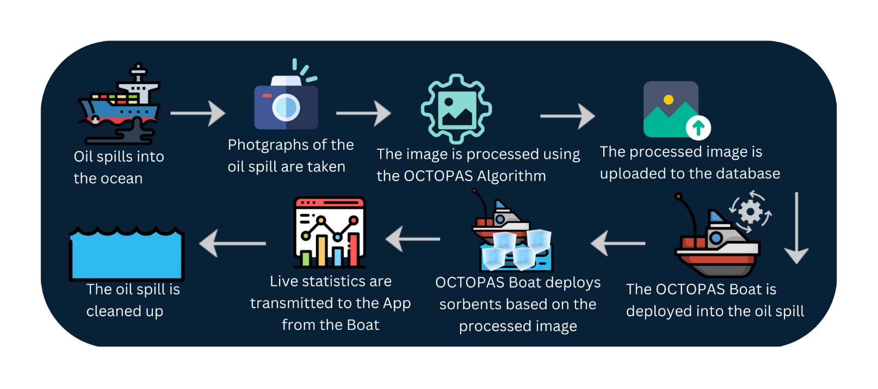
The process of how the OCTOPAS system operates (in the real world) - Figure 1.
The engineering goals for OCTOPAS are as follows:
- Oil Spill Cleanup Efficiency
  - At least 200% improvement over the conventional method
- OCTOPAS Reaction Time
  - Efficiency of the Image Processing Algorithm
    - Processing time must be less than 15 seconds.
- Analytics
  - Displayed through the OCTOPAS App

This research project spans multiple years, with each year building on the knowledge gained from the previous year's findings. In year 1, the focus was on testing the environmental impacts of a novel sorbent, ferrofluid. The results showed that ferrofluid had no effect on one of the most critical environmental issues of our time: ocean acidification. In year 2, the project turned its attention to finding a better solution for oil spill cleanups. Through rigorous testing, both silica aerogel and ferrofluid were shown to be significantly more efficient than traditional methods. However, aerogel emerged as the clear winner, with its superior ability to absorb oil, even when used in the same quantities as ferrofluid. The ongoing work in this project is crucial for addressing some of the most pressing environmental challenges facing our planet.
Year 3 marks a pivotal moment in this multiyear research project, where OCTOPAS - the novel sorbent deployment system - is being constructed and tested, in alignment with rigorous engineering goals, mentioned previously, to ensure it is practical. As mentioned previously, without an efficient deployment method, even the most advanced sorbent will fail to deliver its full potential. The goal of this year’s research is to test OCTOPAS against conventional methods of sorbent deployment, in a bid to push the boundaries of current oil spill cleanup protocols.

Materials and Methods
Parts of OCTOPAS
The main components of OCTOPAS are as follows:
- OCTOPAS Boat (Figure 2)
  - The component that will be traversing through the oil spill
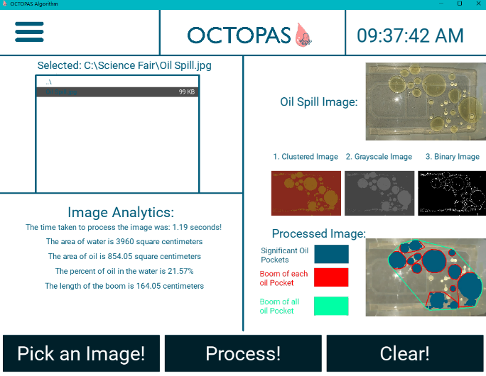
- OCTOPAS App (Figure 3)
Screenshot of the OCTOPAS App, with a processed oil spill image – Figure 3
Screenshot of the OCTOPAS App, with a processed oil spill image – Figure 2.
  - Identifies the oil in an oil spill image and generates the optimal path for cleanup.

Materials
- Arduino Nano - 1
- Power Supply Module - 1
- 9V Battery - 1
- Jumper Wires - As needed.
- 1K Ω Resistor – 1
- 2K Ω Resistor – 1
- Positional Servo - 1
- Bluetooth Module (for Arduino)- 1
- FDM 3D Printer – 1
- PLA Plastic – As needed.
- DC Motors – 2
- AA Batteries – 3
- CAD Software
- Breadboard – 1
- Computer with Internet Connection – 1
- Mobile Phone with Camera – 1
- Peat Moss - 10 grams per trial
- Aerogel - 10 grams per trial
- Water – 5 Gallons per trial
- Motor Oil – 80 ml per trial
- Large Container (at least 35 in (length) * 18 in (width))
- Scale – 1
- Net -1
The investigation was conducted by the student, with advice from parents, and the qualified scientist. The qualified scientist is a researcher from MIT, who has worked in this field.
The investigation was conducted at the student’s house.

Structure of the Investigation:
- Each oil spill cleanup method (total 4) was each tested with 15 trials (total 60 trials)
  - (1) OCTOPAS with Aerogel, (2) Conventional Method with Aerogel,
(3) OCTOPAS with Peat Moss, (4) Conventional Method with Peat Moss
- Data was collected through measuring the weight of the sorbents on a scale.
- Measurements reported are the average of 3 measurements, for each trial.
- Control Group: Conventional sorbent deployment method with peat moss, as it is the method of oil spill cleanup used in the real world.
Equipment and Software Used:
- Scale to measure the weight of sorbents, after taken from the oil spill.
- Net to take out the sorbents from the oil spill.
- OCTOPAS Boat (built by student) to dispense sorbents.
- OCTOPAS App (developed by student) to generate optimal path for OCTOPAS Boat.

Methods:
- Fill the large container with 18.9 liters (5 gallons) of water.
- Add 80ml (70g) of oil to the container and wait 10 minutes for the oil to spread.
- Load OCTOPAS Boat with 10 grams of aerogel.
- Take images, process them using the OCTOPAS App, and record the analytics shown.
- The OCTOPAS Boat’s navigation and sorbent deployment will be remotely controlled based on the processed image.
- Remove the sorbents using the net and record the amount of oil by weighing the sorbents, using the scale (Average of 3 measurements per trial).
- Empty the large container.
- Repeat steps 1-7, 14 times.
- Repeat steps 1-8, but instead of loading the OCTOPAS Boat with aerogel, load it with 10 grams of peat moss.
- Repeat steps 1-8, but instead of letting OCTOPAS deploy the sorbents, evenly spread 10 grams of aerogel across the large container.
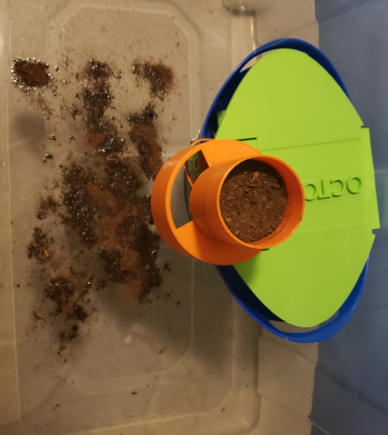
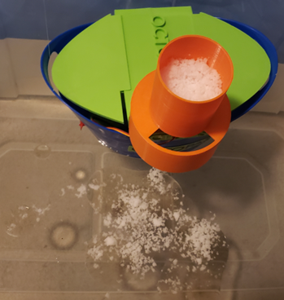
- Repeat step 1-8, but instead of letting OCTOPAS deploy the sorbents, evenly spread 10 grams of peat moss across the large container.
OCTOPAS Boat, deploying aerogel into a pocket of oil – Figure 5.

OCTOPAS Boat, deploying peat moss into a pocket of oil – Figure 4.

Statistical Analysis Tests to Perform:
- ANOVA (Analysis of Variance)
- Tukey HSD (Honest Statistical Difference)

Results
Efficiency of Methods of Oil Spill Cleanup (%)
 | Aerogel | Peat Moss
OCTOPAS | 92.79% | 77.46%
Conventional Method | 29.34% | 24.24%
Average efficiency of each method of oil spill cleanup – Figure 6.
There were 4 methods tested: (1) OCTOPAS with Aerogel, (2) OCTOPAS with Peat Moss, (3) Conventional Method with Aerogel, (4) Conventional Method with Peat Moss. OCTOPAS is the novel sorbent deployment method. Aerogel is the new, highly efficient sorbent. Peat Moss is the conventional sorbent used in the real world. Each of these 4 methods were tested with 15 trials. The average efficiency of each method can be seen in figure 8.
The novel technique of using OCTOPAS with Aerogel as a sorbent demonstrated the highest efficiency rate of 92.8%, followed by OCTOPAS and Peat Moss at 77.46%. In contrast, Aerogel and Peat Moss deployed through conventional methods showed efficiencies of 29.34% and 24.24%, respectively. Utilizing OCTOPAS with any sorbent resulted in an average improvement of more than 215%, compared to using the same sorbent with conventional methods. Moreover, Figures 7 and 8 display that using OCTOPAS to clean up oil spills results in significantly higher efficiency rates, irrespective of the sorbent used, compared to conventional methods without OCTOPAS.

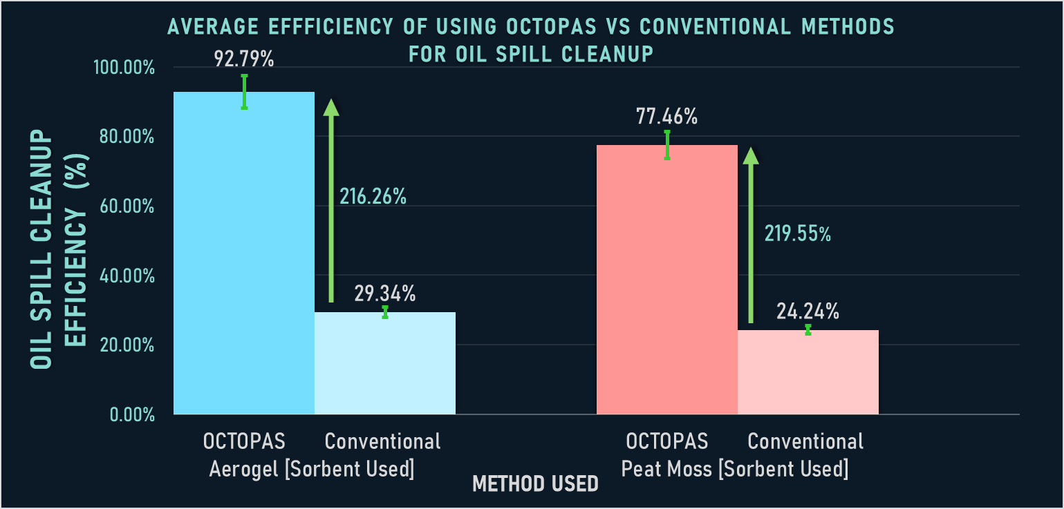
Graph showing the average efficiency using OCTOPAS vs Conventional method for oil spill cleanup, with 95% confidence interval error bars. – Figure 7.

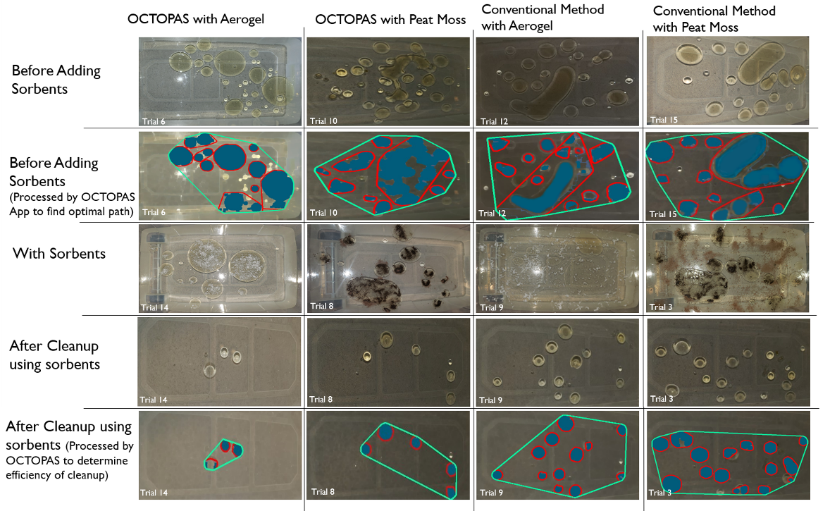
Grid of images from various trials to show the process of OCTOPAS, and a visual representation of how much oil was present before and after each method – Figure 8.

The ANOVA test (figure 9) revealed an extremely low P value of 1.1102 * 10⁻¹⁶, indicating that the results are highly significant and cannot be attributed to mere chance. The Tukey HSD Test (figure 10) confirmed this by showing that the values for each pair were also much lower than 0.01, signifying that every comparison made was meaningful and not a fluke. These findings provide evidence that the results obtained are valid and reliable.
ANOVA Test – Figure 9.
Tukey's HSD (honestly significant difference) – Figure 10.
Group A – OCTOPAS with Aerogel
Group B – OCTOPAS with Peat Moss
Group C – Conventional Method with Aerogel
Group D – Conventional Method with Peat Moss

Discussion
The aim of this project was to revolutionize the field of oil spill cleanups by developing a novel sorbent deployment method that surpasses current methods in efficiency. The result was OCTOPAS, which proved to be a tremendous improvement, being 215% more efficient than conventional methods, irrespective of the sorbent used. This meets and exceeds the engineering criteria established at the project's outset, as OCTOPAS was designed to be 200% more efficient. The impact of this discovery is staggering, as it could lead to an increase in oil recovery from 30% to over 90%. Additionally, OCTOPAS is practical, with a processing time of less than 15 seconds and real-time analytics displayed on the app. In addition, it is automatic, as compared to most conventional methods which are manual.
This novel improvement in the field of oil spill cleanups is groundbreaking, as most of the research in this field has been focused on finding more efficient sorbents, rather than developing a more effective way to deploy them. By using OCTOPAS in combination with highly efficient sorbents, such as Aerogel or other high-performance sorbents, nearly all the oil from an oil spill could be cleaned up.
This breakthrough will benefit everyone impacted by oil spills, from local and national government agencies to fishing and tourism industries, and the public. OCTOPAS will save these industries and agencies from the significant financial losses associated with oil spills, and it will safeguard the health and safety of local communities by preventing oil contamination of seafood and water sources. This discovery could be of great interest to local and national government agencies responsible for environmental protection, as well as to researchers in the field of oil spill remediation. In summary, OCTOPAS represents a significant leap forward in oil spill cleanups, with the potential to have a massive positive impact on the environment and all those who rely on it.

Conclusions
To revolutionize oil spill cleanups, this project aimed to create OCTOPAS, a groundbreaking sorbent deployment system that would surpass conventional methods in both efficiency and practicality. Traditional deployment methods have proven to be a limiting factor in oil spill cleanups, even with the most effective sorbents. OCTOPAS surpassed all expectations by automatically and pragmatically distributing sorbents throughout the spill. Its superior efficiency was evident, regardless of the sorbent used, making OCTOPAS an essential tool in all future oil spill cleanups.

- Engineering Goals
With the same sorbent, OCTOPAS was around 215% more effective than typical methods of sorbent dispersion. OCTOPAS was also able to process the images much faster than the goal of 15 seconds, on average it only took around 5 seconds. OCTOPAS was also successfully able to show the analytics of the oil spill as well.

- Impacts
OCTOPAS, a novel sorbent deployment method for oil spill cleanups, has proven to be 215% more efficient than conventional methods, with the potential to increase oil recovery from 30% to over 90%. This technology also has practical advantages such as real-time analytics and quick processing time, making it a valuable tool for local and national government agencies and coastal communities.

- Real World Usage
One of the major advantages to OCTOPAS is that it can be easily stored on the oil tankers, so if an oil spill occurs, OCTOPAS can be instantly deployed, wasting no time. This increased efficiency presents the potential to rescue countless aquatic creatures, thwart the catastrophic destruction of ecosystems, and preserve entire economies from ruin.

- Future
The future plans for OCTOPAS is to incorporate cutting-edge AI/ML technology to enhance its already impressive adaptability and efficiency. In addition, one of the major plans for OCTOPAS is to add automatic sorbent cleanup, to improve its practicality in the real world.

References
Aerogel.org. (n.d.). Silica Aerogel. [online] Available at: https://www.aerogel.org/?p=16 [Accessed 12 Oct. 2022].
Edmond, C. (2021). How do oil spills affect the environment? [online] World Economic Forum. Available at: http://www.weforum.org/agenda/2021/10/oil-spill-environment-ocean [Accessed 12 Oct. 2022].
ITOPF. (2023b). Tanker spill statistics 2022123123. [online] Available at: https://www.itopf.org/news-events/news/tanker-spill-statistics-2022/ [Accessed 12 Jan. 2023].
National Oceanic and Atmospheric Administration (2020). Oil spills | national oceanic and atmospheric administration. [online] www.noaa.gov. Available at: https://www.noaa.gov/education/resource-collections/ocean-coasts/oil-spills [Accessed 11 Apr. 2023].
NOAA (2021). How does oil impact marine life? [online] National Ocean Service. Available at: https://oceanservice.noaa.gov/facts/oilimpacts.html [Accessed 12 Oct. 2022].
PeatSorb Safety Data Sheet (2018). [online] NugenTec. Available at: https://www.nugentec.com/documents/Peat-Sorb-US-EN-sds.pdf [Accessed 11 Apr. 2023].

Bibliography
Aerogel.org. (n.d.). Silica Aerogel. [online] Available at: https://www.aerogel.org/?p=16 [Accessed 12 Oct. 2022].
docs.opencv.org. (n.d.). OpenCV: Image Processing in OpenCV. [online] Available at: https://docs.opencv.org/4.x/d2/d96/tutorial_py_table_of_contents_imgproc.html [Accessed 12 Oct. 2022].
Edmond, C. (2021). How do oil spills affect the environment? [online] World Economic Forum. Available at: http://www.weforum.org/agenda/2021/10/oil-spill-environment-ocean [Accessed 12 Oct. 2022].
Etkin, D.S. and Nedwed, T.J. (2021). Effectiveness of mechanical recovery for large offshore oil spills. Marine Pollution Bulletin, 163, p.111848. doi:https://doi.org/10.1016/j.marpolbul.2020.111848.
Helton, D. (2022). What Have We Learned About Using Dispersants During the Next Big Oil Spill? [online] response.restoration.noaa.gov. Available at: http://response.restoration.noaa.gov/about/media/what-have-we-learned-about-using-dispersants-during-next-big-oil-spill.html [Accessed 12 Oct. 2022].
ITOPF (2023a). Oil Tanker Spill Statistics 2022. [online] Itopf.org. Available at: https://www.itopf.org/knowledge-resources/data-statistics/statistics/ [Accessed 6 Mar. 2023].
ITOPF. (2023b). Tanker spill statistics 2022123123. [online] Available at: https://www.itopf.org/news-events/news/tanker-spill-statistics-2022/ [Accessed 12 Jan. 2023].
Kivy Developers (2022). Kivy Documentation Release 2.2.0.dev0 The Kivy Developers. [online] Read the Docs. Available at: https://buildmedia.readthedocs.org/media/pdf/kivy/latest/kivy.pdf [Accessed 12 Oct. 2022].
National Oceanic and Atmospheric Administration (2020). Oil spills | national oceanic and atmospheric administration. [online] www.noaa.gov. Available at: https://www.noaa.gov/education/resource-collections/ocean-coasts/oil-spills [Accessed 11 Apr. 2023].
NOAA (2019). Spill Containment Methods. [online] NOAA Office of Response and Restoration. Available at: https://response.restoration.noaa.gov/oil-and-chemical-spills/oil-spills/spill-containment-methods.html [Accessed 12 Oct. 2022].
NOAA (2021). How does oil impact marine life? [online] National Ocean Service. Available at: https://oceanservice.noaa.gov/facts/oilimpacts.html [Accessed 12 Oct. 2022].
Pandey, S. and Alam, A. (2019). Peat moss: A hypersorbent for oil spill cleanupa review. Plant Science Today, 6, p.416. doi:https://doi.org/10.14719/pst.2019.6.4.586.
PeatSorb Safety Data Sheet (2018). [online] NugenTec. Available at: https://www.nugentec.com/documents/Peat-Sorb-US-EN-sds.pdf [Accessed 11 Apr. 2023].
Society for Science (n.d.). INTERNATIONAL RULES FOR PRE-COLLEGE SCIENCE RESEARCH GUIDELINES FOR SCIENCE AND ENGINEERING FAIRS 2022–2023. [online] Society for Science. Available at: https://sspcdn.blob.core.windows.net/files/Documents/SEP/ISEF/2023/Rules/Book.pdf [Accessed 12 Oct. 2022].
SSEF Florida. (2022). State Science & Engineering Fair of Florida RULES SUPPLEMENT to the International Science & Engineering Fair Rules. [online] Available at: https://ssefflorida.com/wp-content/uploads/2022/08/SSEF-Rules-Supplement_2022_23.pdf [Accessed 25 Dec. 2022].
UCLA: Statistical Consulting Group (n.d.). What statistical analysis should I use? Statistical analyses using SPSS. [online] stats.oarc.ucla.edu. Available at: https://stats.oarc.ucla.edu/spss/whatstat/what-statistical-analysis-should-i-usestatistical-analyses-using-spss/ [Accessed 25 Dec. 2022].

